CEE 671 Finite Element Analysis Homework #4
Shibo Wang April 18, 2008
Singularity problems: point-load half-space and crack problems
Analyze the two problems below, and illustrate that the FE analysis yields the given closed-form solutions: to do this, you must (1) determine the size of the mesh that approximates an elastic-half space (i.e. something with semi-infinite dimensions), and (2) demonstrate that the FEA stress distributions agree with the analytical solutions for locations outside an arbitrary radial distance that is dictated by the mesh distribution. Comment on the difference in convergence with respect to stresses and displacements.

Hints: use log-log plots to illustrate agreement in terms of the power-law dependence of the spatial distribution. Section 3 in the following reference discusses meshing considerations for crack problems (which are also applicable to point-load singularities).

Solution:
Crack-Tip problem:
Analytical solution:
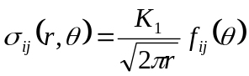
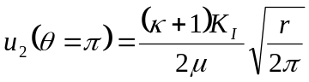
Plane Stress: 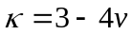
Plane Strain: 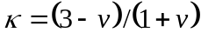
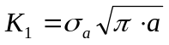
when 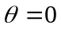, 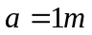, 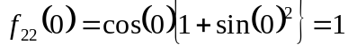, 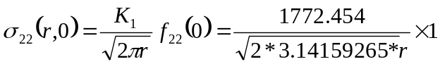
when 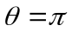, 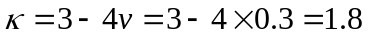(plane stress)
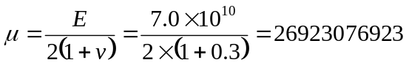, 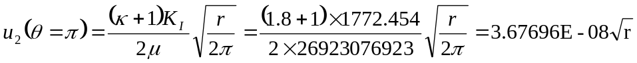
where r is the distance from crack tip, and u₂ represents the displacement as function of position for crack face.
Determine the mesh: 5043 nodes and 1220 elements are used. The coordinate of the crack tip is (1,0), 20 elements are used in each row. Totally, 61 rows are included. When , the results of both FEA simulation and the analytical solution are obtained and shown below. And there is the input file in the appendix.
r | S22-FEA | S22-ANA | Discrepancy% | log r | logS22-FEA | LogS22-ANA
0.00E+00 | 2.71E+06 | #DIV/0! | #DIV/0! | #NUM! | 6.433113 | #DIV/0!
0.00E+00 | 2.75E+06 | #DIV/0! | #DIV/0! | #NUM! | 6.439489 | #DIV/0!
0.00E+00 | 2.86E+06 | #DIV/0! | #DIV/0! | #NUM! | 6.457043 | #DIV/0!
0.00E+00 | 3.03E+06 | #DIV/0! | #DIV/0! | #NUM! | 6.481713 | #DIV/0!
0.00E+00 | 3.22E+06 | #DIV/0! | #DIV/0! | #NUM! | 6.508368 | #DIV/0!
0.00E+00 | 3.40E+06 | #DIV/0! | #DIV/0! | #NUM! | 6.532071 | #DIV/0!
0.00E+00 | 3.54E+06 | #DIV/0! | #DIV/0! | #NUM! | 6.548704 | #DIV/0!
0.00E+00 | 3.59E+06 | #DIV/0! | #DIV/0! | #NUM! | 6.555036 | #DIV/0!
0.00E+00 | 3.54E+06 | #DIV/0! | #DIV/0! | #NUM! | 6.548498 | #DIV/0!
0.00E+00 | 3.36E+06 | #DIV/0! | #DIV/0! | #NUM! | 6.526877 | #DIV/0!
0.00E+00 | 3.08E+06 | #DIV/0! | #DIV/0! | #NUM! | 6.488009 | #DIV/0!
0.00E+00 | 2.69E+06 | #DIV/0! | #DIV/0! | #NUM! | 6.429504 | #DIV/0!
0.00E+00 | 2.23E+06 | #DIV/0! | #DIV/0! | #NUM! | 6.348459 | #DIV/0!
0.00E+00 | 1.74E+06 | #DIV/0! | #DIV/0! | #NUM! | 6.24117 | #DIV/0!
0.00E+00 | 1.27E+06 | #DIV/0! | #DIV/0! | #NUM! | 6.102831 | #DIV/0!
0.00E+00 | 845948 | #DIV/0! | #DIV/0! | #NUM! | 5.927344 | #DIV/0!
0.00E+00 | 510029 | #DIV/0! | #DIV/0! | #NUM! | 5.707595 | #DIV/0!
0.00E+00 | 273357 | #DIV/0! | #DIV/0! | #NUM! | 5.43673 | #DIV/0!
0.00E+00 | 126727 | #DIV/0! | #DIV/0! | #NUM! | 5.102869 | #DIV/0!
0.00E+00 | 32156.9 | #DIV/0! | #DIV/0! | #NUM! | 4.507274 | #DIV/0!
1.68E-02 | 5561.52 | 5461.139368 | 1.83809 | -1.7756 | 3.745194 | 3.7372833
3.34E-02 | 4061.47 | 3867.380031 | 5.018642 | -1.47586 | 3.608683 | 3.5874169
6.68E-02 | 2841.68 | 2736.700049 | 3.836005 | -1.17548 | 3.453575 | 3.4372272
1.00E-01 | 2380.6 | 2235.062614 | 6.511557 | -0.99961 | 3.376686 | 3.3492897
1.33E-01 | 2110.5 | 1935.862783 | 9.021157 | -0.87478 | 3.324385 | 3.2868746
1.67E-01 | 1929.82 | 1731.618103 | 11.44605 | -0.77793 | 3.285517 | 3.2384521
2.00E-01 | 1799.25 | 1580.82283 | 13.81731 | -0.6988 | 3.255092 | 3.1988832
2.33E-01 | 1699.95 | 1463.609802 | 16.14776 | -0.63188 | 3.230436 | 3.1654253
2.67E-01 | 1621.62 | 1369.118268 | 18.44265 | -0.57391 | 3.209949 | 3.136441
3.00E-01 | 1558.14 | 1290.843968 | 20.70708 | -0.52278 | 3.192606 | 3.1108737
3.33E-01 | 1505.57 | 1224.622518 | 22.94156 | -0.47703 | 3.177701 | 3.0880022
3.67E-01 | 1461.3 | 1167.647677 | 25.14905 | -0.43565 | 3.164739 | 3.0673118
4.00E-01 | 1423.49 | 1117.95024 | 27.33035 | -0.39787 | 3.153354 | 3.0484225
4.33E-01 | 1390.82 | 1074.102174 | 29.48675 | -0.36312 | 3.143271 | 3.0310456
4.67E-01 | 1362.31 | 1035.039283 | 31.61916 | -0.33094 | 3.134276 | 3.0149568
5.00E-01 | 1337.22 | 999.9500879 | 33.72867 | -0.30099 | 3.126203 | 2.9999783
5.33E-01 | 1314.97 | 968.20356 | 35.81545 | -0.27296 | 3.118916 | 2.9859667
5.67E-01 | 1295.11 | 939.3006019 | 37.88025 | -0.24664 | 3.112307 | 2.9728046
0.60004 | 1277.28 | 912.8405785 | 39.92367 | -0.22182 | 3.106286 | 2.9603949
0.63337 | 1261.19 | 888.4976721 | 41.94635 | -0.19834 | 3.100781 | 2.9486563
0.6667 | 1246.61 | 866.0038268 | 43.94971 | -0.17607 | 3.095731 | 2.9375198
0.70003 | 1233.33 | 845.136216 | 45.93269 | -0.15488 | 3.091079 | 2.9269267
0.73336 | 1221.2 | 825.7078806 | 47.89734 | -0.13468 | 3.086787 | 2.9168264
0.76669 | 1210.08 | 807.5606321 | 49.84386 | -0.11538 | 3.082814 | 2.9071751
0.80002 | 1199.85 | 790.5595996 | 51.77224 | -0.0969 | 3.079127 | 2.8979346
0.83335 | 1190.4 | 774.5889885 | 53.6815 | -0.07917 | 3.075693 | 2.8890713
0.86668 | 1181.67 | 759.5487465 | 55.57527 | -0.06214 | 3.072496 | 2.8805557
0.90001 | 1173.57 | 745.3519144 | 57.4518 | -0.04575 | 3.069509 | 2.8723614
0.93334 | 1166.04 | 731.9225023 | 59.31195 | -0.02996 | 3.066713 | 2.8644651
0.96667 | 1159.03 | 719.1937727 | 61.15685 | -0.01472 | 3.064095 | 2.8568459
1 | 1152.45 | 707.1068407 | 62.98103 | 0 | 3.061622 | 2.849485
1.15 | 1127.92 | 659.3805289 | 71.05752 | 0.060698 | 3.052278 | 2.8191361
1.3 | 1109.21 | 620.1737251 | 78.85472 | 0.113943 | 3.045014 | 2.7925134
1.45 | 1094.5 | 587.2202689 | 86.38662 | 0.161368 | 3.039216 | 2.768801
1.6 | 1082.69 | 559.0170414 | 93.67746 | 0.20412 | 3.034504 | 2.747425
1.75 | 1073.05 | 534.5225288 | 100.7493 | 0.243038 | 3.03062 | 2.727966
1.9 | 1065.07 | 512.9892192 | 107.6203 | 0.278754 | 3.027378 | 2.7101082
2.05 | 1058.38 | 493.8648399 | 114.3056 | 0.311754 | 3.024642 | 2.6936081
2.2 | 1052.71 | 476.7313347 | 120.8183 | 0.342423 | 3.022309 | 2.6782737
2.35 | 1047.87 | 461.2656428 | 127.1728 | 0.371068 | 3.020307 | 2.6639511
2.5 | 1043.69 | 447.2136331 | 133.3762 | 0.39794 | 3.018572 | 2.650515
2.65 | 1040.06 | 434.3722793 | 139.4398 | 0.423246 | 3.017058 | 2.6378621
2.8 | 1036.89 | 422.5771629 | 145.3729 | 0.447158 | 3.015733 | 2.625906
2.95 | 1034.1 | 411.6935194 | 151.182 | 0.469822 | 3.014563 | 2.614574
3.1 | 1031.62 | 401.6096982 | 156.8713 | 0.491362 | 3.01352 | 2.6038042
3.25 | 1029.42 | 392.2323033 | 162.4516 | 0.511883 | 3.012593 | 2.5935434
3.4 | 1027.46 | 383.4825267 | 167.9288 | 0.531479 | 3.011765 | 2.5837456
3.55 | 1025.69 | 375.2933441 | 173.3035 | 0.550228 | 3.011016 | 2.5743709
3.7 | 1024.09 | 367.607342 | 178.5826 | 0.568202 | 3.010338 | 2.5653842
3.85 | 1022.62 | 360.3750154 | 183.7655 | 0.585461 | 3.009714 | 2.5567547
4 | 1020.61 | 353.5534203 | 188.6721 | 0.60206 | 3.00886 | 2.548455
8.5 | 1005.9 | 242.5356454 | 314.7432 | 0.929419 | 3.002555 | 2.3847756
13 | 1002.97 | 196.1161516 | 411.4163 | 1.113943 | 3.001288 | 2.2925134
17.5 | 1001.84 | 169.0308652 | 492.6965 | 1.243038 | 3.000798 | 2.227966
22 | 1001.26 | 150.755685 | 564.1607 | 1.342423 | 3.000547 | 2.1782737
26.5 | 1000.88 | 137.3605755 | 628.6516 | 1.423246 | 3.000382 | 2.1378621
31 | 1000.61 | 127.0001377 | 687.881 | 1.491362 | 3.000265 | 2.1038042
35.5 | 1000.38 | 118.6781758 | 742.9351 | 1.550228 | 3.000165 | 2.0743709
40 | 1000.15 | 111.8034083 | 794.5613 | 1.60206 | 3.000065 | 2.048455
44.5 | 999.914 | 105.9997969 | 843.3169 | 1.64836 | 2.999963 | 2.025305
49 | 999.61 | 101.015263 | 889.5633 | 1.690196 | 2.999831 | 2.004387
Plot S22 vs r and log S22 vs log r
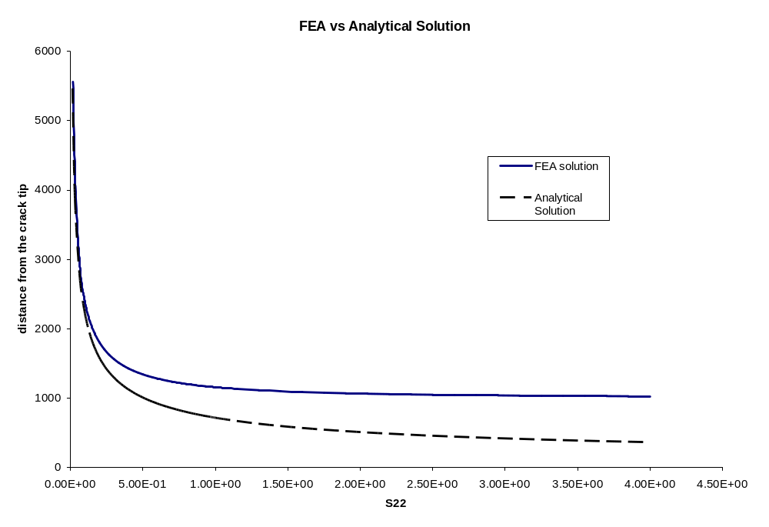
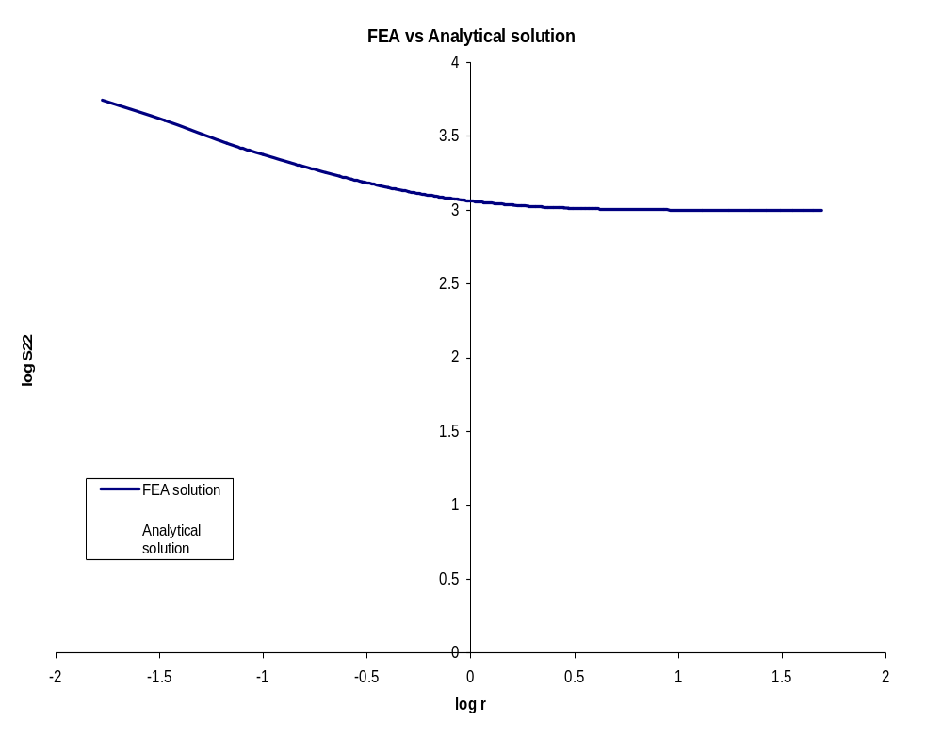
Based on the results from the S22-r and log S22-log r, it can be included that in this crack problem, the analytical solution is only valid for regions that are very near the crack tip. Since the length of the crack is 1, within 0.133, about 9% error is obtained and within 0.3, about the error is confined below 20%.
When , the displacement distribution along the y direction is simulated. The results are shown below.
r | U2-FEA | U2-ANA | Discrepancy% | log r | log U22-FEA | log U22-ANA
0 | 7.65E-36 | 0 | #DIV/0! | #NUM! | -35.11613651 | #NUM!
0 | -3.63E-13 | 0 | #DIV/0! | #NUM! | #NUM! | #NUM!
0 | -7.20E-13 | 0 | #DIV/0! | #NUM! | #NUM! | #NUM!
0 | -1.07E-12 | 0 | #DIV/0! | #NUM! | #NUM! | #NUM!
0 | -1.41E-12 | 0 | #DIV/0! | #NUM! | #NUM! | #NUM!
0 | -1.77E-12 | 0 | #DIV/0! | #NUM! | #NUM! | #NUM!
0 | -2.15E-12 | 0 | #DIV/0! | #NUM! | #NUM! | #NUM!
0 | -2.58E-12 | 0 | #DIV/0! | #NUM! | #NUM! | #NUM!
0 | -3.09E-12 | 0 | #DIV/0! | #NUM! | #NUM! | #NUM!
0 | -3.69E-12 | 0 | #DIV/0! | #NUM! | #NUM! | #NUM!
0 | -4.39E-12 | 0 | #DIV/0! | #NUM! | #NUM! | #NUM!
0 | -5.18E-12 | 0 | #DIV/0! | #NUM! | #NUM! | #NUM!
0 | -6.04E-12 | 0 | #DIV/0! | #NUM! | #NUM! | #NUM!
0 | -6.95E-12 | 0 | #DIV/0! | #NUM! | #NUM! | #NUM!
0 | -7.89E-12 | 0 | #DIV/0! | #NUM! | #NUM! | #NUM!
0 | -8.84E-12 | 0 | #DIV/0! | #NUM! | #NUM! | #NUM!
0 | -9.80E-12 | 0 | #DIV/0! | #NUM! | #NUM! | #NUM!
0 | -1.08E-11 | 0 | #DIV/0! | #NUM! | #NUM! | #NUM!
0 | -1.17E-11 | 0 | #DIV/0! | #NUM! | #NUM! | #NUM!
0 | -1.25E-11 | 0 | #DIV/0! | #NUM! | #NUM! | #NUM!
0.0138278 | 4.54E-09 | 4.32379E-09 | 5.113719713 | -1.859246911 | -8.342475668 | -8.364135073
0.03343 | 7.29E-09 | 6.7229E-09 | 8.459316004 | -1.475863623 | -8.137176568 | -8.172443429
0.06676 | 1.02E-08 | 9.5005E-09 | 7.770096506 | -1.175483672 | -7.989755182 | -8.022253454
0.10009 | 1.24E-08 | 1.16328E-08 | 6.926237086 | -0.999609311 | -7.90523199 | -7.934316273
0.13342 | 1.42E-08 | 1.34307E-08 | 6.035376963 | -0.874779064 | -7.846450365 | -7.87190115
0.16675 | 1.58E-08 | 1.50149E-08 | 5.113863207 | -0.777934157 | -7.801818699 | -7.823478696
0.20008 | 1.71E-08 | 1.64471E-08 | 4.174382953 | -0.698796321 | -7.766148842 | -7.783909778
0.23341 | 1.83E-08 | 1.77643E-08 | 3.218812222 | -0.631880541 | -7.736693031 | -7.750451888
0.26674 | 1.94E-08 | 1.89903E-08 | 2.251000901 | -0.573911853 | -7.711799976 | -7.721467544
0.30007 | 2.04E-08 | 2.01419E-08 | 1.271160531 | -0.522777422 | -7.690414542 | -7.695900329
0.3334 | 2.13E-08 | 2.1231E-08 | 0.279140056 | -0.477034405 | -7.671818219 | -7.67302882
0.36673 | 2.21E-08 | 2.2267E-08 | -0.723467577 | -0.435653562 | -7.655491799 | -7.652338398
0.40006 | 2.29E-08 | 2.32569E-08 | -1.737780215 | -0.397874869 | -7.641062482 | -7.633449052
0.43339 | 2.35E-08 | 2.42063E-08 | -2.763612132 | -0.363121114 | -7.628243357 | -7.616072175
0.46672 | 2.42E-08 | 2.51198E-08 | -3.801076701 | -0.330943588 | -7.616813201 | -7.599983412
0.50005 | 2.47E-08 | 2.60013E-08 | -4.850149993 | -0.300986568 | -7.606596794 | -7.585004902
0.53338 | 2.53E-08 | 2.68539E-08 | -5.911483411 | -0.272963273 | -7.597456633 | -7.570993254
0.56671 | 2.57E-08 | 2.76802E-08 | -6.985412277 | -0.246639124 | -7.589280114 | -7.55783118
0.60004 | 2.62E-08 | 2.84825E-08 | -8.07205392 | -0.221819798 | -7.58197396 | -7.545421516
0.63337 | 2.66E-08 | 2.92629E-08 | -9.172315562 | -0.198342511 | -7.575464631 | -7.533682873
0.6667 | 2.69E-08 | 3.0023E-08 | -10.28634866 | -0.176069545 | -7.569687857 | -7.52254639
0.70003 | 2.73E-08 | 3.07643E-08 | -11.41446201 | -0.154883348 | -7.564590465 | -7.511953292
0.73336 | 2.75E-08 | 3.14881E-08 | -12.55723258 | -0.134682782 | -7.560129115 | -7.501853008
0.76669 | 2.78E-08 | 3.21957E-08 | -13.71557757 | -0.115380201 | -7.556269322 | -7.492201718
0.80002 | 2.80E-08 | 3.28881E-08 | -14.88958407 | -0.096899156 | -7.552978483 | -7.482961196
0.83335 | 2.82E-08 | 3.35662E-08 | -16.07985142 | -0.07917256 | -7.550231654 | -7.474097898
0.86668 | 2.83E-08 | 3.42309E-08 | -17.28720036 | -0.062141225 | -7.548009509 | -7.46558223
0.90001 | 2.84E-08 | 3.48829E-08 | -18.51154893 | -0.045752665 | -7.546291887 | -7.45738795
0.93334 | 2.85E-08 | 3.55229E-08 | -19.75287488 | -0.029960121 | -7.545062196 | -7.449491678
0.96667 | 2.86E-08 | 3.61516E-08 | -21.00902494 | -0.014721759 | -7.544295023 | -7.441872497
1 | 2.86E-08 | 3.67696E-08 | -22.26938987 | 0 | -7.543919541 | -7.434511618
Plot the result normally and in a double log way:
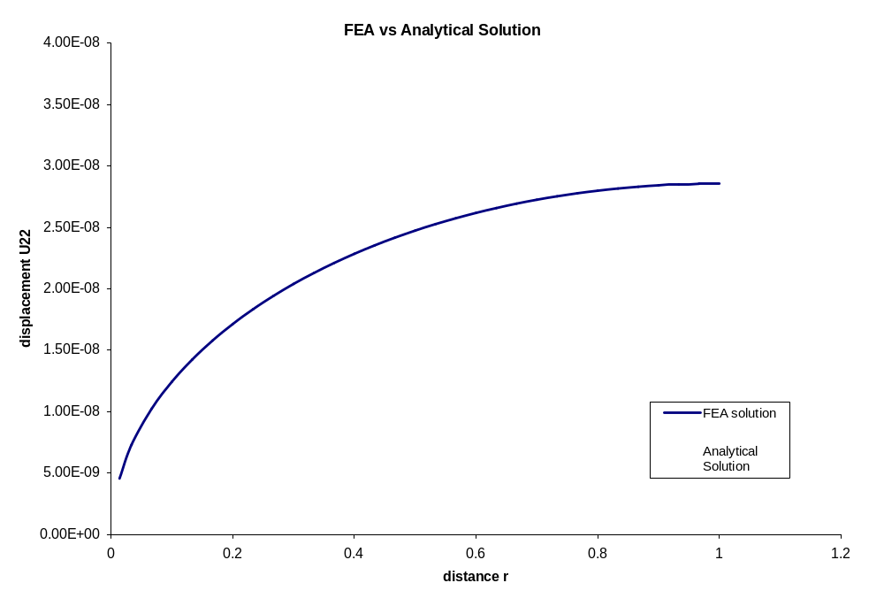
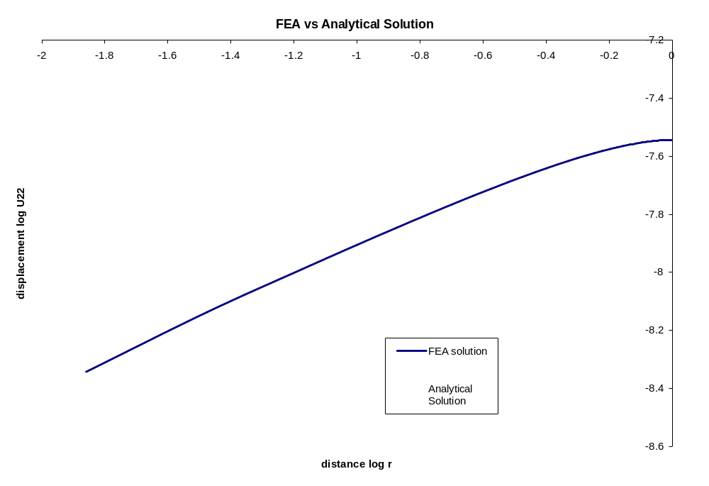
Based on the results of simulated and analytical displacement, it is shown that FEA can provide fairly satisfied results. Compared to the general shape of that of stress, in both cases, the results converge near where the singularity happens. However, it can be found that for displacement, more accurate results can be obtained. Besides, it can be seen that after getting divergent from the analytical solution, the FEA curve for stress is above that of the analytical solution, while the FEA curve for displacement is below the analytical curve. In another word, FEA provides overestimation for stress and underestimation for displacement.
Another mesh is tried: 4779 nodes and 1160 elements are used to simulate the displacement and stress fields. The coordinate of the crack tip is (1,0), 40 elements are used in each row. Totally, 29 rows are included. The results of both FEA simulation and the analytical solution are shown below. And there is the input file in the appendix.
r | S22-FEA | S22-ANA | Discrepancy% | log r | logS22-FEA | LogS22-ANA
0 | -710467 | #DIV/0! | #DIV/0! | #NUM! | #NUM! | #DIV/0!
1.97E-06 | 2.56E+07 | 504183.2 | 4980.296114 | -5.70620668 | 7.408477405 | 5.702588379
2.04E-06 | 2.59E+07 | 494476.7 | 5142.451463 | -5.68932155 | 7.413680234 | 5.694145816
4.01E-06 | -710467 | 352961.4 | -301.2874593 | -5.39648431 | #NUM! | 5.547727192
5.98E-06 | 2.59E+07 | 289111.1 | 8866.346036 | -5.2231594 | 7.413680234 | 5.461064738
6.06E-06 | 2.64E+07 | 287267.6 | 9097.450719 | -5.21760335 | 7.421954182 | 5.458286713
6.13E-06 | 2.71E+07 | 285492.8 | 9387.561082 | -5.21222012 | 7.432749684 | 5.455595099
6.21E-06 | 2.79E+07 | 283794 | 9726.246552 | -5.2070364 | 7.445390895 | 5.453003238
6.35E-06 | 2.88E+07 | 280671.3 | 10155.16215 | -5.19742603 | 7.459140584 | 5.448198053
6.42E-06 | 2.97E+07 | 279168.7 | 10550.87134 | -5.1927634 | 7.473251876 | 5.445866738
6.48E-06 | 3.07E+07 | 277758.9 | 10949.68928 | -5.18836602 | 7.487018114 | 5.443668049
6.62E-06 | 3.16E+07 | 274926.9 | 11396.73075 | -5.17946424 | 7.499791521 | 5.43921716
6.67E-06 | 3.24E+07 | 273736.4 | 11748.66006 | -5.17569515 | 7.511001851 | 5.437332612
6.80E-06 | 3.31E+07 | 271096.7 | 12118.923 | -5.16727846 | 7.520157198 | 5.43312427
6.85E-06 | 3.36E+07 | 270133.4 | 12352.55185 | -5.16418645 | 7.526836622 | 5.431578263
6.98E-06 | 3.39E+07 | 267665.4 | 12579.15272 | -5.15621427 | 7.530682406 | 5.427592173
7.02E-06 | 3.40E+07 | 266932.6 | 12634.63942 | -5.15383305 | 7.531388217 | 5.426401564
7.14E-06 | 3.38E+07 | 264611.2 | 12666.61651 | -5.14624644 | 7.528684072 | 5.422608259
7.17E-06 | 3.33E+07 | 264109.1 | 12505.13323 | -5.14459655 | 7.522330754 | 5.421783314
7.29E-06 | 3.25E+07 | 261906.2 | 12315.43952 | -5.13732133 | 7.5121078 | 5.418145701
7.41E-06 | 3.15E+07 | 259773.2 | 12011.71751 | -5.13021872 | 7.49780013 | 5.414594397
7.42E-06 | 3.01E+07 | 259611.6 | 11510.99977 | -5.12967804 | 7.479193677 | 5.414324061
7.54E-06 | 2.86E+07 | 257549.8 | 10997.03637 | -5.12275251 | 7.456068303 | 5.410861293
7.60E-06 | 2.68E+07 | 256536.1 | 10348.19685 | -5.119327 | 7.428189888 | 5.409148541
7.72E-06 | 2.48E+07 | 254541.1 | 9662.115695 | -5.11254587 | 7.395301925 | 5.405757975
7.78E-06 | 2.28E+07 | 253532.2 | 8876.294113 | -5.10909633 | 7.357130276 | 5.404033202
7.84E-06 | 2.06E+07 | 252506.8 | 8048.85124 | -5.10557593 | 7.313369394 | 5.402273004
7.91E-06 | 1.84E+07 | 251458.8 | 7198.45253 | -5.10196355 | 7.263697599 | 5.400466811
8.03E-06 | 1.61E+07 | 249515.3 | 6366.536276 | -5.09522443 | 7.20776897 | 5.397097252
8.10E-06 | 1.40E+07 | 248421.4 | 5524.073754 | -5.09140776 | 7.145239927 | 5.395188919
8.18E-06 | 1.19E+07 | 247296.7 | 4714.864149 | -5.08746655 | 7.075802354 | 5.393218316
8.25E-06 | 9.98E+06 | 246141.7 | 3955.46506 | -5.08340026 | 6.999225832 | 5.391185168
8.33E-06 | 8.23E+06 | 244957.9 | 3260.108516 | -5.07921269 | 6.915444687 | 5.389091384
8.42E-06 | 6.68E+06 | 243747.9 | 2639.949347 | -5.07491182 | 6.824683482 | 5.386940948
8.50E-06 | 5.34E+06 | 242515.4 | 2102.099429 | -5.07050853 | 6.727576227 | 5.384739303
8.57E-06 | 4.22E+06 | 241589.5 | 1646.243308 | -5.06718593 | 6.625182761 | 5.383078006
8.66E-06 | 3.30E+06 | 240319.1 | 1273.282446 | -5.0626065 | 6.518548156 | 5.380788287
8.75E-06 | 2.55E+06 | 239039.5 | 967.7149344 | -5.05796912 | 6.406924914 | 5.378469597
8.82E-06 | 1.92E+06 | 238039.7 | 704.9498706 | -5.05432859 | 6.282418171 | 5.376649336
8.90E-06 | 1.29E+06 | 237026.9 | 446.1701232 | -5.05062512 | 6.112125539 | 5.374797599
9.00E-06 | 523835 | 235740.5 | 122.2082938 | -5.04589842 | 5.719194512 | 5.372434248
1.10E-05 | 2.55E+07 | 213490.1 | 11848.75009 | -4.95978545 | 7.406700244 | 5.329377766
0.050011 | 3222.28 | 3161.933 | 1.908538232 | -1.30093533 | 3.508163276 | 3.499952704
0.100011 | 2302.87 | 2235.945 | 2.993132759 | -0.99995223 | 3.362269422 | 3.349461154
0.150011 | 1968.7 | 1825.675 | 7.834084525 | -0.82387689 | 3.294179541 | 3.261423486
0.200011 | 1777.95 | 1581.095 | 12.45051412 | -0.69894612 | 3.249919543 | 3.198958098
0.250011 | 1653.53 | 1414.183 | 16.92479001 | -0.60204088 | 3.218412079 | 3.15050548
0.300011 | 1565.78 | 1290.971 | 21.28701061 | -0.52286282 | 3.194730741 | 3.110916449
0.350011 | 1500.57 | 1195.21 | 25.5486559 | -0.45591831 | 3.17625626 | 3.077444192
0.400011 | 1450.23 | 1118.019 | 29.71428714 | -0.39792807 | 3.161436885 | 3.048449072
0.450011 | 1410.22 | 1054.08 | 33.78683995 | -0.34677687 | 3.14928687 | 3.022873474
0.50001 | 1377.67 | 999.9901 | 37.76836607 | -0.30102131 | 3.139145201 | 2.999995694
0.55001 | 1350.67 | 953.454 | 41.66074059 | -0.25962941 | 3.130549254 | 2.979299746
0.60001 | 1327.88 | 912.8634 | 45.46316587 | -0.22184151 | 3.12315883 | 2.960405794
0.65001 | 1308.36 | 877.0513 | 49.17712687 | -0.18707996 | 3.116727258 | 2.94302502
0.70001 | 1291.42 | 845.1483 | 52.80395366 | -0.15489576 | 3.111067508 | 2.926932917
0.75001 | 1276.53 | 816.4912 | 56.3433862 | -0.12493295 | 3.106031026 | 2.911951512
0.80001 | 1263.3 | 790.5645 | 59.79720001 | -0.09690458 | 3.101506496 | 2.897937331
0.85001 | 1251.41 | 766.9605 | 63.1648477 | -0.07057596 | 3.097399621 | 2.884773021
0.90001 | 1240.66 | 745.3519 | 66.45291655 | -0.04575267 | 3.09365278 | 2.872361371
0.95001 | 1230.72 | 725.4725 | 69.64392339 | -0.02227182 | 3.090159258 | 2.86062095
1.00001 | 1190.94 | 707.1033 | 68.42517795 | 4.34292E-06 | 3.075889882 | 2.849482867
7.00001 | 1007.11 | 267.2611 | 276.8262945 | 0.84509866 | 3.003076908 | 2.426935708
13 | 1002.52 | 196.1162 | 411.1868613 | 1.113943352 | 3.001093045 | 2.292513363
19 | 1001.53 | 162.2214 | 517.3845037 | 1.278753601 | 3.000663963 | 2.210108238
25 | 1000.91 | 141.4214 | 607.7501888 | 1.397940009 | 3.000395028 | 2.150515034
31 | 1000.55 | 127.0001 | 687.8337916 | 1.491361694 | 3.000238796 | 2.103804192
37 | 1000.27 | 116.2476 | 760.4647171 | 1.568201724 | 3.000117244 | 2.065384177
43 | 1000.01 | 107.8328 | 827.3710452 | 1.633468456 | 3.000004343 | 2.032750811
49 | 999.68 | 101.0153 | 889.6326266 | 1.69019608 | 2.999861004 | 2.004386999
Based on the above results, it is seen that 1.9% discrepancy can be realized at region very close to where the singularity happens. Plot stess vs distance from the crack tip in both a normal way and a double-log way. It is seen that stress simulated by FEA is getting asymptotic to the applied distributed load 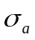, which is 1000 N in this case.
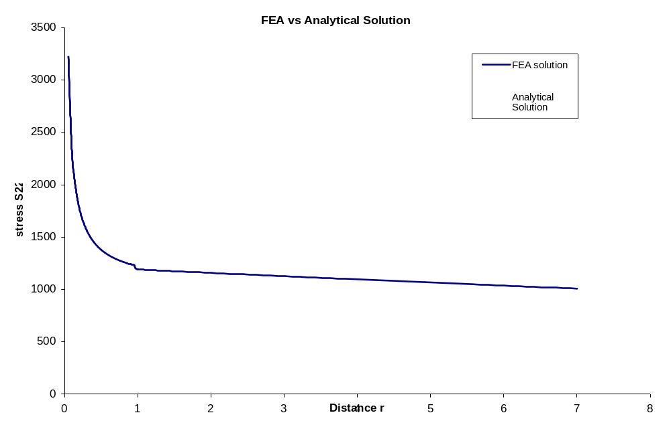
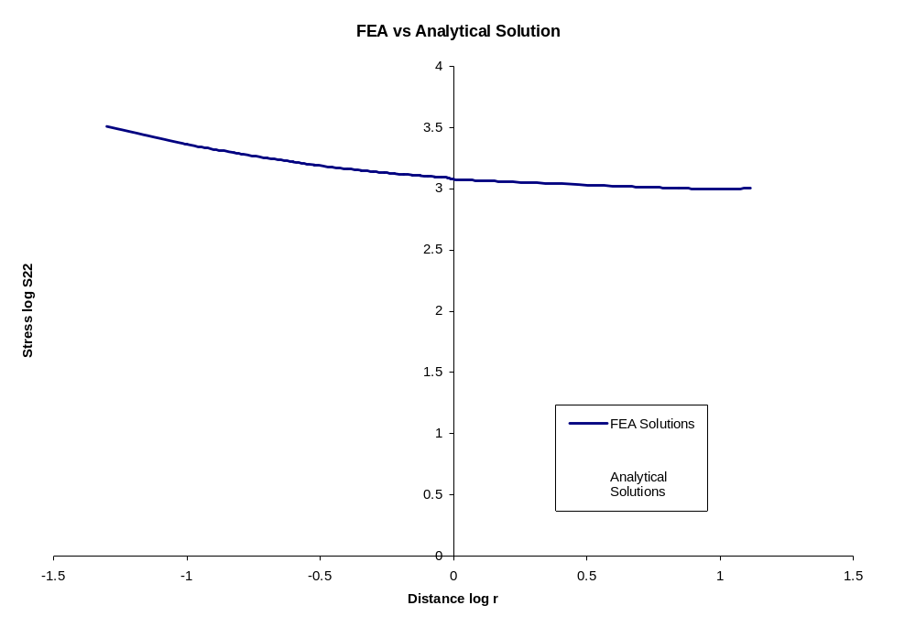
Also, the displacement distribution is simulated and plotted.
r | U2-FEA | U2-ANA | Discrepancy% | log r | log U22-FEA | log U22-ANA
0 | 8.06E-35 | 0 | #DIV/0! | #NUM! | -34.0937 | #NUM!
7.85E-08 | 2.10E-11 | 1.03E-11 | 103.4331 | -7.10536 | -10.6788 | -10.9872
1.56E-07 | 4.23E-11 | 1.45E-11 | 190.5419 | -6.80567 | -10.3741 | -10.8373
2.33E-07 | 6.42E-11 | 1.78E-11 | 261.6218 | -6.63182 | -10.1922 | -10.7504
3.09E-07 | 8.72E-11 | 2.04E-11 | 326.8599 | -6.51002 | -10.0592 | -10.6895
3.83E-07 | 1.12E-10 | 2.27E-11 | 390.5049 | -6.41716 | -9.95245 | -10.6431
5.22E-07 | 1.37E-10 | 2.66E-11 | 417.709 | -6.28267 | -9.86176 | -10.5758
5.90E-07 | 1.65E-10 | 2.82E-11 | 484.9118 | -6.22907 | -9.78196 | -10.549
6.55E-07 | 1.95E-10 | 2.98E-11 | 554.9434 | -6.1835 | -9.71006 | -10.5263
7.90E-07 | 2.27E-10 | 3.27E-11 | 594.3515 | -6.10259 | -9.64423 | -10.4858
8.47E-07 | 2.61E-10 | 3.38E-11 | 671.266 | -6.07198 | -9.5833 | -10.4705
9.78E-07 | 2.98E-10 | 3.64E-11 | 718.2452 | -6.00973 | -9.52649 | -10.4394
1.03E-06 | 3.36E-10 | 3.73E-11 | 802.7356 | -5.98866 | -9.47328 | -10.4288
1.15E-06 | 3.77E-10 | 3.95E-11 | 855.5033 | -5.93802 | -9.42329 | -10.4035
1.19E-06 | 4.20E-10 | 4.01E-11 | 947.5305 | -5.92381 | -9.37625 | -10.3964
1.32E-06 | 4.66E-10 | 4.22E-11 | 1004.137 | -5.88094 | -9.33196 | -10.375
1.34E-06 | 5.13E-10 | 4.26E-11 | 1103.067 | -5.87206 | -9.29025 | -10.3705
1.46E-06 | 5.61E-10 | 4.45E-11 | 1161.202 | -5.83455 | -9.251 | -10.3518
1.58E-06 | 6.11E-10 | 4.63E-11 | 1219.908 | -5.80028 | -9.21411 | -10.3347
1.59E-06 | 6.62E-10 | 4.64E-11 | 1325.343 | -5.79775 | -9.17947 | -10.3334
1.71E-06 | 7.13E-10 | 4.81E-11 | 1381.522 | -5.7664 | -9.14701 | -10.3177
1.77E-06 | 7.64E-10 | 4.89E-11 | 1461.825 | -5.75152 | -9.11664 | -10.3103
1.89E-06 | 8.16E-10 | 5.06E-11 | 1513.583 | -5.72317 | -9.0883 | -10.2961
1.95E-06 | 8.67E-10 | 5.14E-11 | 1587.384 | -5.70926 | -9.06193 | -10.2891
2.02E-06 | 9.17E-10 | 5.22E-11 | 1656.964 | -5.69541 | -9.03745 | -10.2822
2.08E-06 | 9.66E-10 | 5.31E-11 | 1721.604 | -5.68153 | -9.01482 | -10.2753
2.21E-06 | 1.01E-09 | 5.46E-11 | 1756.827 | -5.65647 | -8.99397 | -10.2627
2.28E-06 | 1.06E-09 | 5.55E-11 | 1809.918 | -5.64273 | -8.97486 | -10.2559
2.35E-06 | 1.10E-09 | 5.64E-11 | 1856.641 | -5.62886 | -8.95743 | -10.2489
2.43E-06 | 1.14E-09 | 5.73E-11 | 1896.684 | -5.61488 | -8.94164 | -10.242
2.51E-06 | 1.18E-09 | 5.82E-11 | 1929.855 | -5.6008 | -8.92745 | -10.2349
2.59E-06 | 1.22E-09 | 5.92E-11 | 1956.037 | -5.58667 | -8.91482 | -10.2278
2.68E-06 | 1.25E-09 | 6.01E-11 | 1975.243 | -5.57253 | -8.90371 | -10.2208
2.74E-06 | 1.28E-09 | 6.09E-11 | 1996.308 | -5.56206 | -8.89408 | -10.2155
2.83E-06 | 1.30E-09 | 6.19E-11 | 2001.55 | -5.5479 | -8.88592 | -10.2085
2.92E-06 | 1.32E-09 | 6.29E-11 | 2000.193 | -5.53388 | -8.87919 | -10.2015
3.00E-06 | 1.34E-09 | 6.37E-11 | 1999.849 | -5.52308 | -8.87386 | -10.1961
3.07E-06 | 1.35E-09 | 6.45E-11 | 1992.911 | -5.51227 | -8.86989 | -10.1906
3.17E-06 | 1.36E-09 | 6.55E-11 | 1973.206 | -5.49872 | -8.86723 | -10.1839
3.25E-06 | 1.36E-09 | 6.63E-11 | 1955.089 | -5.48818 | -8.86577 | -10.1786
0.050003 | 8.32E-09 | 8.22E-09 | 1.209585 | -1.301 | -8.07979 | -8.08501
0.100003 | 1.16E-08 | 1.16E-08 | -0.37349 | -0.99999 | -7.93613 | -7.93451
0.150003 | 1.39E-08 | 1.42E-08 | -2.11665 | -0.8239 | -7.85575 | -7.84646
0.200003 | 1.58E-08 | 1.64E-08 | -3.92587 | -0.69896 | -7.80139 | -7.78399
0.250003 | 1.73E-08 | 1.84E-08 | -5.78295 | -0.60205 | -7.76141 | -7.73554
0.300003 | 1.86E-08 | 2.01E-08 | -7.67897 | -0.52287 | -7.73065 | -7.69595
0.350003 | 1.97E-08 | 2.18E-08 | -9.61307 | -0.45593 | -7.70637 | -7.66248
0.400003 | 2.06E-08 | 2.33E-08 | -11.5849 | -0.39794 | -7.68695 | -7.63348
0.450003 | 2.13E-08 | 2.47E-08 | -13.5967 | -0.34678 | -7.67137 | -7.6079
0.500003 | 2.19E-08 | 2.6E-08 | -15.6514 | -0.30103 | -7.65895 | -7.58503
0.550003 | 2.24E-08 | 2.73E-08 | -17.7527 | -0.25963 | -7.64921 | -7.56433
0.600003 | 2.28E-08 | 2.85E-08 | -19.906 | -0.22185 | -7.64183 | -7.54543
0.650003 | 2.31E-08 | 2.96E-08 | -22.1181 | -0.18708 | -7.63662 | -7.52805
0.700003 | 2.33E-08 | 3.08E-08 | -24.3982 | -0.1549 | -7.63343 | -7.51196
0.750003 | 2.33E-08 | 3.18E-08 | -26.7582 | -0.12494 | -7.63222 | -7.49698
0.800002 | 2.33E-08 | 3.29E-08 | -29.2162 | -0.09691 | -7.63303 | -7.48297
0.850002 | 2.31E-08 | 3.39E-08 | -31.7965 | -0.07058 | -7.636 | -7.4698
0.900002 | 2.28E-08 | 3.49E-08 | -34.5719 | -0.04576 | -7.64163 | -7.45739
0.950002 | 2.24E-08 | 3.58E-08 | -37.6122 | -0.02228 | -7.65055 | -7.44565
1 | 2.15E-08 | 3.68E-08 | -41.4187 | 0 | -7.66675 | -7.43451
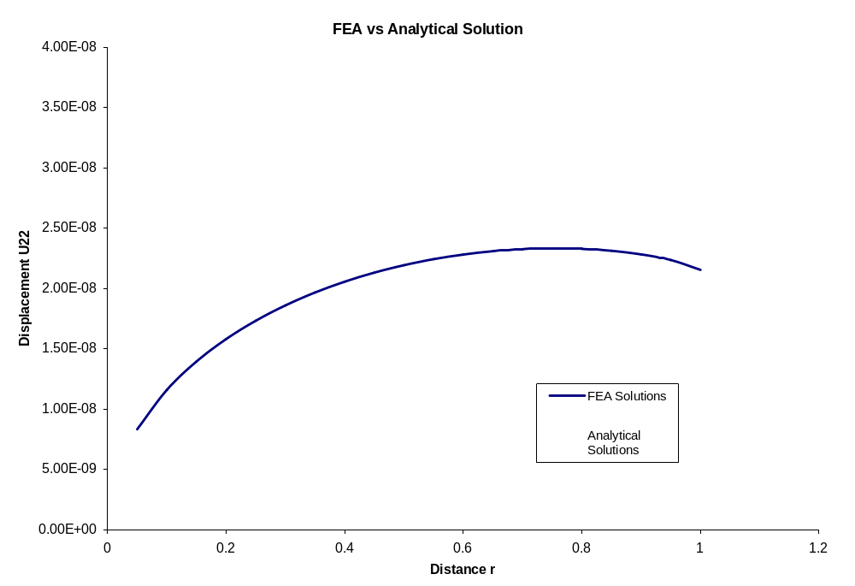
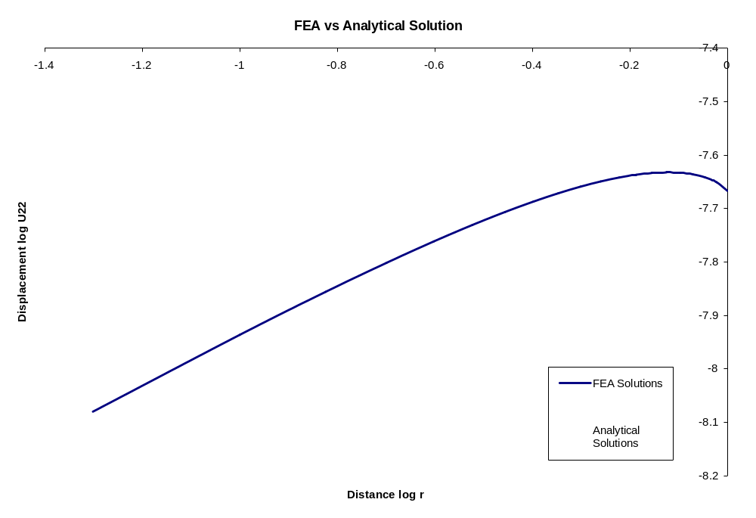

Point-Load Problem:
Analytical solution:
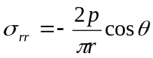
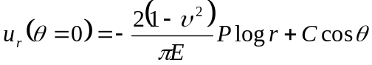
where r is the distance from the load point, and u_{r} represents the displacement as function of position along r. C is an arbituary constant which has different value with respect to different meshes.
when , 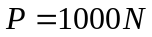, 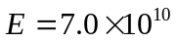, 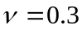, 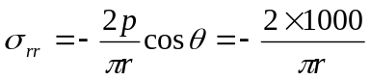,
Determine the mesh: 14823 nodes and 3640 elements are used. The coordinate of the point load is (15,30), 40 elements are used in each row. Totally, 91 rows are included. When , the results of both FEA simulation and the analytical solution are obtained and shown below. And there is the input file in the appendix.
r | S22-FEA | S22-ANA | Discrepancy% | log r | logS22-FEA | LogS22-ANA
0 | -2.35E+08 | #DIV/0! | #DIV/0! | #NUM! | 8.37172896 | #DIV/0!
0 | -2.34E+08 | #DIV/0! | #DIV/0! | #NUM! | 8.36867358 | #DIV/0!
1.91E-06 | -2.28E+08 | -3.3E+08 | -31.6554 | -5.71957 | 8.35815384 | 8.52345
1.91E-06 | -2.25E+08 | -3.3E+08 | -32.6906 | -5.71957 | 8.35152575 | 8.52345
3.81E-06 | -2.24E+08 | -1.7E+08 | 34.03526 | -5.41854 | 8.3496388 | 8.22242
3.81E-06 | -2.25E+08 | -1.7E+08 | 34.89273 | -5.41854 | 8.35240829 | 8.22242
4.77E-06 | -2.29E+08 | -1.3E+08 | 71.24328 | -5.32163 | 8.35912372 | 8.12551
6.68E-06 | -2.34E+08 | -9.5E+07 | 145.0823 | -5.1755 | 8.36869402 | 7.979382
7.63E-06 | -2.40E+08 | -8.3E+07 | 187.3851 | -5.11751 | 8.37985461 | 7.92139
7.63E-06 | -2.46E+08 | -8.3E+07 | 195.0718 | -5.11751 | 8.39131804 | 7.92139
9.76E-06 | -2.52E+08 | -6.5E+07 | 286.8653 | -5.01047 | 8.40190692 | 7.814347
9.76E-06 | -2.57E+08 | -6.5E+07 | 294.6764 | -5.01047 | 8.4105883 | 7.814347
1.07E-05 | -2.61E+08 | -5.9E+07 | 339.1754 | -4.96999 | 8.41650571 | 7.773868
1.17E-05 | -2.62E+08 | -5.5E+07 | 380.961 | -4.93296 | 8.41894893 | 7.736839
1.36E-05 | -2.61E+08 | -4.7E+07 | 457.5126 | -4.86721 | 8.41734379 | 7.671089
1.45E-05 | -2.58E+08 | -4.4E+07 | 488.311 | -4.83773 | 8.41121552 | 7.641609
1.55E-05 | -2.51E+08 | -4.1E+07 | 511.1548 | -4.81012 | 8.40015101 | 7.614
1.64E-05 | -2.42E+08 | -3.9E+07 | 524.8005 | -4.78416 | 8.38378306 | 7.588042
1.64E-05 | -2.30E+08 | -3.9E+07 | 493.8938 | -4.78416 | 8.36175049 | 7.588042
2.34E-05 | -6.50E+07 | -2.7E+07 | 138.5582 | -4.63115 | 7.81262262 | 7.435028
3.24E-05 | 7.56E+06 | -2E+07 | -138.43 | -4.48976 | #NUM! | 7.293638
4.59E-05 | -1.99E+08 | -1.4E+07 | 1334.67 | -4.33852 | 8.29915632 | 7.142404
5.94E-05 | 7.56E+06 | -1.1E+07 | -170.446 | -4.22657 | #NUM! | 7.030449
6.13E-05 | 8.08E+06 | -1E+07 | -177.793 | -4.21283 | #NUM! | 7.016712
6.13E-05 | 8.80E+06 | -1E+07 | -184.648 | -4.21283 | #NUM! | 7.016712
6.32E-05 | 9.00E+06 | -1E+07 | -189.292 | -4.19952 | #NUM! | 7.003396
6.32E-05 | 8.19E+06 | -1E+07 | -181.229 | -4.19952 | #NUM! | 7.003396
6.41E-05 | 5.96E+06 | -9928599 | -160.048 | -4.19301 | #NUM! | 6.996888
6.60E-05 | 2.01E+06 | -9641795 | -120.889 | -4.18028 | #NUM! | 6.984158
6.70E-05 | -3.89E+06 | -9504511 | -59.1007 | -4.17405 | 6.58964582 | 6.97793
6.70E-05 | -1.19E+07 | -9504511 | 25.11532 | -4.17405 | 7.07524029 | 6.97793
6.91E-05 | -2.21E+07 | -9211248 | 139.5386 | -4.16044 | 7.34369409 | 6.964318
6.91E-05 | -3.44E+07 | -9211248 | 273.299 | -4.16044 | 7.53637534 | 6.964318
7.01E-05 | -4.87E+07 | -9085885 | 436.5168 | -4.15449 | 7.68795057 | 6.958367
7.52E-05 | -1.81E+08 | -8465396 | 2038.163 | -4.12377 | 8.25768817 | 6.927647
7.62E-05 | -1.62E+08 | -8359384 | 1834.221 | -4.11829 | 8.20868048 | 6.922174
7.62E-05 | -1.42E+08 | -8359384 | 1595.089 | -4.11829 | 8.15136679 | 6.922174
7.71E-05 | -1.22E+08 | -8255995 | 1372.251 | -4.11289 | 8.08475139 | 6.916769
7.81E-05 | -1.02E+08 | -8155142 | 1147.556 | -4.10755 | 8.00749173 | 6.911432
7.90E-05 | -8.27E+07 | -8056714 | 926.9385 | -4.10228 | 7.91770239 | 6.906158
8.09E-05 | -6.50E+07 | -7866817 | 725.7025 | -4.09192 | 7.81262262 | 6.895799
8.70E-05 | -2.16E+08 | -7321154 | 2845.096 | -4.0607 | 8.33367897 | 6.86458
0.050086 | -6916.97 | -12710.5 | -45.5806 | -1.30028 | 3.83991589 | 4.104162
0.100087 | -6045.51 | -6360.66 | -4.95473 | -0.99962 | 3.78143294 | 3.803502
0.150087 | -4155.83 | -4241.67 | -2.02377 | -0.82366 | 3.61865777 | 3.627537
0.200086 | -3146.83 | -3181.73 | -1.09691 | -0.69878 | 3.49787328 | 3.502663
0.250085 | -2527.6 | -2545.61 | -0.70763 | -0.60191 | 3.40270835 | 3.405792
0.300084 | -2110.93 | -2121.47 | -0.49691 | -0.52276 | 3.32447383 | 3.326637
0.350084 | -1811.69 | -1818.48 | -0.37324 | -0.45583 | 3.25808389 | 3.259708
0.400083 | -1586.56 | -1591.22 | -0.29281 | -0.39785 | 3.2004565 | 3.20173
0.450082 | -1411.08 | -1414.45 | -0.23846 | -0.34671 | 3.14955164 | 3.150588
0.500083 | -1270.49 | -1273.03 | -0.19938 | -0.30096 | 3.10397125 | 3.104838
0.550082 | -1155.35 | -1157.32 | -0.17004 | -0.25957 | 3.06271357 | 3.063453
0.600082 | -1059.31 | -1060.89 | -0.14874 | -0.22179 | 3.02502307 | 3.02567
0.650081 | -978.005 | -979.293 | -0.13152 | -0.18703 | 2.99034108 | 2.990913
0.70008 | -908.279 | -909.353 | -0.11809 | -0.15485 | 2.95821927 | 2.958732
0.750079 | -847.826 | -848.737 | -0.10733 | -0.12489 | 2.92830673 | 2.928773
0.800079 | -794.913 | -795.696 | -0.09842 | -0.09687 | 2.9003196 | 2.900747
0.85008 | -748.213 | -748.894 | -0.09093 | -0.07054 | 2.87402525 | 2.87442
0.900079 | -706.694 | -707.293 | -0.08472 | -0.04572 | 2.8492314 | 2.849599
0.950078 | -669.538 | -670.071 | -0.07955 | -0.02224 | 2.82577523 | 2.826121
1.00008 | -634.286 | -636.569 | -0.35862 | 3.47E-05 | 2.80228513 | 2.803845
1.20008 | -527.562 | -530.481 | -0.55028 | 0.07921 | 2.72227351 | 2.72467
1.40008 | -452.834 | -454.702 | -0.41091 | 0.146153 | 2.65593903 | 2.657727
1.60008 | -396.591 | -397.867 | -0.32083 | 0.204142 | 2.59834285 | 2.599738
1.80008 | -352.746 | -353.662 | -0.25899 | 0.255292 | 2.5474621 | 2.548588
2.00008 | -317.616 | -318.297 | -0.214 | 0.301047 | 2.50190237 | 2.502833
2.20008 | -288.841 | -289.362 | -0.18009 | 0.342438 | 2.46065884 | 2.461442
2.40008 | -264.843 | -265.249 | -0.15321 | 0.380226 | 2.4229885 | 2.423654
2.60008 | -244.526 | -244.846 | -0.13079 | 0.414987 | 2.38832504 | 2.388893
2.80008 | -227.104 | -227.358 | -0.11159 | 0.44717 | 2.35622478 | 2.35671
3.00008 | -212.001 | -212.201 | -0.09422 | 0.477133 | 2.32633791 | 2.326747
3.20008 | -198.783 | -198.939 | -0.07827 | 0.505161 | 2.29837924 | 2.298719
3.40008 | -187.12 | -187.237 | -0.06233 | 0.531489 | 2.27212021 | 2.272391
3.60008 | -176.753 | -176.835 | -0.04631 | 0.556312 | 2.24736679 | 2.247568
3.80008 | -167.478 | -167.528 | -0.02984 | 0.579793 | 2.22395777 | 2.224087
4.00008 | -159.132 | -159.152 | -0.01242 | 0.602069 | 2.20175752 | 2.201811
4.20008 | -151.583 | -151.573 | 0.006433 | 0.623258 | 2.1806505 | 2.180623
4.40008 | -144.722 | -144.684 | 0.026484 | 0.643461 | 2.16053456 | 2.16042
4.60008 | -138.461 | -138.393 | 0.048994 | 0.662765 | 2.14132746 | 2.141115
4.80008 | -132.723 | -132.627 | 0.072452 | 0.681248 | 2.12294619 | 2.122632
5.00008 | -127.364 | -127.322 | 0.033052 | 0.698977 | 2.10504669 | 2.104903
5.50008 | -115.804 | -115.747 | 0.048929 | 0.740369 | 2.06372356 | 2.063511
6.00008 | -106.281 | -106.102 | 0.168818 | 0.778157 | 2.02645563 | 2.025723
6.50008 | -98.2413 | -97.9403 | 0.307332 | 0.812919 | 1.9922941 | 1.990961
7.00008 | -91.3709 | -90.9446 | 0.4687 | 0.845103 | 1.9608079 | 1.958777
7.50008 | -85.4402 | -84.8817 | 0.657938 | 0.875066 | 1.93166226 | 1.928814
8.00008 | -80.2761 | -79.5767 | 0.878931 | 0.903094 | 1.90458627 | 1.900786
8.50008 | -75.7462 | -74.8957 | 1.135527 | 0.929423 | 1.87936085 | 1.874457
9.00008 | -71.7473 | -70.7349 | 1.431257 | 0.954246 | 1.85580556 | 1.849634
9.50008 | -68.1979 | -67.012 | 1.769617 | 0.977727 | 1.833771 | 1.826153
10.0001 | -65.0324 | -63.6613 | 2.153677 | 1.000004 | 1.81312978 | 1.803876
10.5001 | -62.1979 | -60.6299 | 2.586221 | 1.021193 | 1.79377572 | 1.782687
11.0001 | -59.6506 | -57.874 | 3.069775 | 1.041397 | 1.77561482 | 1.762483
11.5001 | -57.3544 | -55.3578 | 3.606794 | 1.060702 | 1.75856674 | 1.743179
12.0001 | -55.2792 | -53.0512 | 4.199705 | 1.079185 | 1.74256175 | 1.724695
12.5001 | -53.3993 | -50.9292 | 4.850119 | 1.096913 | 1.72753556 | 1.706967
13.0001 | -51.693 | -48.9704 | 5.559739 | 1.113947 | 1.71343174 | 1.689933
13.5001 | -50.1416 | -47.1567 | 6.329813 | 1.130337 | 1.70019819 | 1.673543
14.0001 | -48.7292 | -45.4725 | 7.161873 | 1.146131 | 1.68778928 | 1.657749
14.5001 | -47.4416 | -43.9045 | 8.056327 | 1.161371 | 1.67615933 | 1.642509
15.0001 | -46.2668 | -42.441 | 9.014306 | 1.176094 | 1.66526946 | 1.627786
15.5001 | -45.1939 | -41.072 | 10.03585 | 1.190335 | 1.65507982 | 1.613546
16.0001 | -44.2135 | -39.7885 | 11.12134 | 1.204123 | 1.6455549 | 1.599757
16.5001 | -43.3171 | -38.5828 | 12.27054 | 1.217487 | 1.63665937 | 1.586394
17.0001 | -42.4974 | -37.448 | 13.48376 | 1.230451 | 1.62836236 | 1.573429
17.5001 | -41.7477 | -36.3781 | 14.76064 | 1.243041 | 1.62063255 | 1.56084
18.0001 | -41.0619 | -35.3676 | 16.10043 | 1.255275 | 1.61343904 | 1.548605
18.5001 | -40.4347 | -34.4117 | 17.50279 | 1.267174 | 1.60675423 | 1.536706
19.0001 | -39.8612 | -33.5061 | 18.9669 | 1.278756 | 1.60055037 | 1.525124
19.5001 | -39.3371 | -32.647 | 20.49223 | 1.290037 | 1.59480234 | 1.513843
20.0001 | -38.8583 | -31.8308 | 22.07756 | 1.301032 | 1.5894838 | 1.502848
20.5001 | -38.4214 | -31.0545 | 23.7226 | 1.311756 | 1.58457319 | 1.492124
21.0001 | -38.0231 | -30.3151 | 25.42634 | 1.322221 | 1.58004752 | 1.481659
21.5001 | -37.6603 | -29.6101 | 27.18741 | 1.33244 | 1.57588378 | 1.47144
22.0001 | -37.3306 | -28.9371 | 29.00588 | 1.342425 | 1.57206497 | 1.461455
22.5001 | -37.0314 | -28.2941 | 30.88035 | 1.352184 | 1.56857013 | 1.451696
23.0001 | -36.7606 | -27.679 | 32.81043 | 1.36173 | 1.56538259 | 1.44215
23.5001 | -36.5162 | -27.0901 | 34.79543 | 1.37107 | 1.56248558 | 1.43281
24.0001 | -36.2964 | -26.5257 | 36.83477 | 1.380213 | 1.55986355 | 1.423667
24.5001 | -36.0996 | -25.9844 | 38.92811 | 1.389168 | 1.55750239 | 1.414712
25.0001 | -35.9244 | -25.4647 | 41.07535 | 1.397942 | 1.55538952 | 1.405938
25.5001 | -35.7695 | -24.9654 | 43.27639 | 1.406542 | 1.55351287 | 1.397338
26.0001 | -35.6338 | -24.4853 | 45.53151 | 1.414975 | 1.55186214 | 1.388905
26.5001 | -35.5163 | -24.0233 | 47.84107 | 1.423248 | 1.55042772 | 1.380633
27.0001 | -35.4161 | -23.5784 | 50.20555 | 1.431365 | 1.54920074 | 1.372515
27.5001 | -35.3325 | -23.1497 | 52.626 | 1.439334 | 1.54817437 | 1.364546
28.0001 | -35.2649 | -22.7363 | 55.10369 | 1.44716 | 1.54734266 | 1.356721
28.5001 | -35.2128 | -22.3375 | 57.64014 | 1.454846 | 1.54670056 | 1.349034
29.0001 | -35.1758 | -21.9523 | 60.2372 | 1.462399 | 1.54624398 | 1.341481
29.5001 | -35.1538 | -21.5803 | 62.89796 | 1.469823 | 1.54597228 | 1.334057
30.0001 | -35.147 | -21.2206 | 65.62689 | 1.477123 | 1.54588826 | 1.326757
Plot FEA results vs Analytical solution in both normal way and a double-log way.
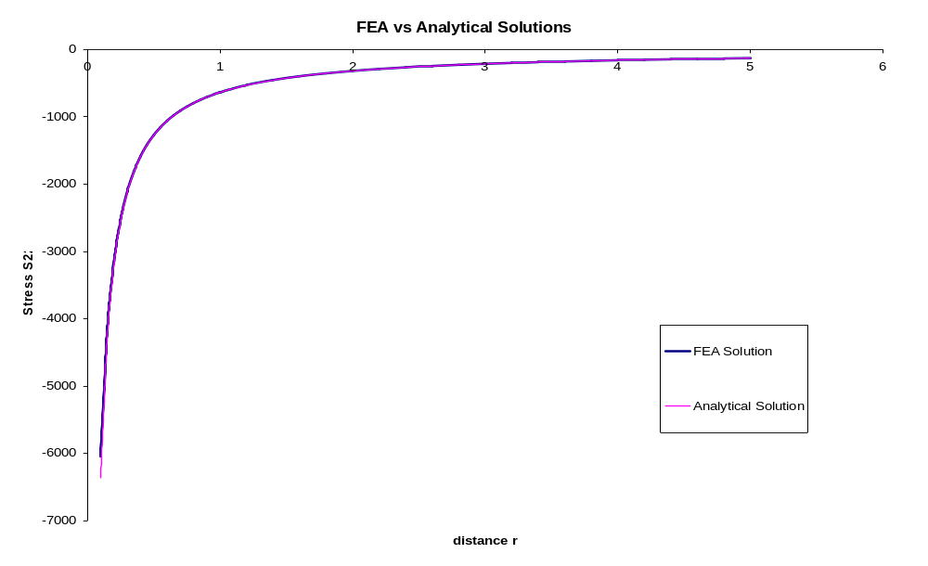
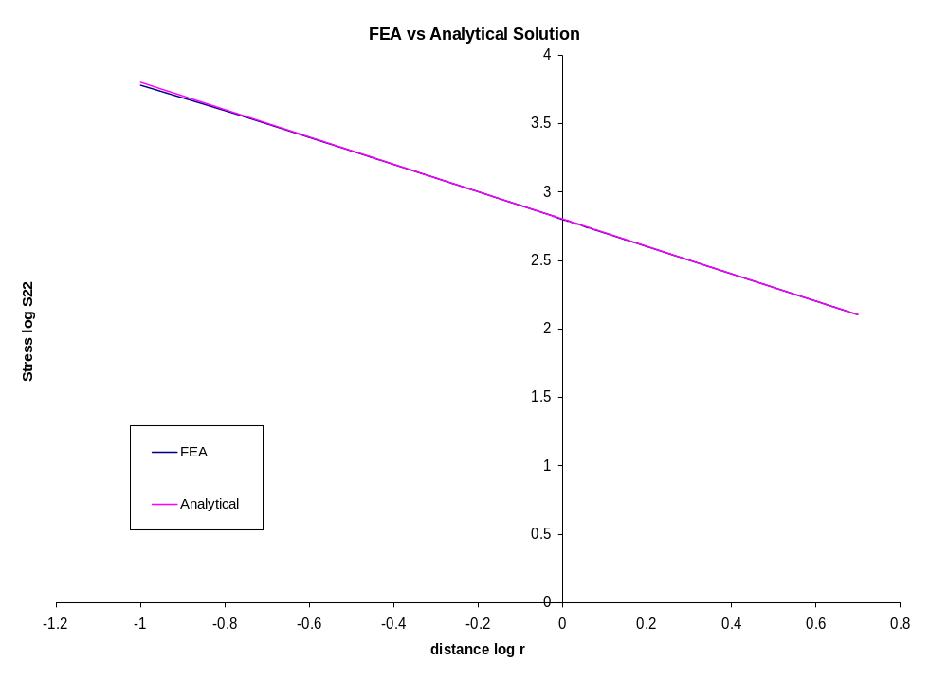
Based on the above results, FEA results matches “perfect” with the analytical solution in the region that is very close to the load-point.
Also, the results of displacement when are obtained and plotted.
r | U2-FEA | U2-ANA | Difference | log r | log U22-FEA | log U22-ANA
0 | -8.38E-08 | #NUM! | #NUM! | #NUM! | -7.07681 | #NUM!
0 | -8.36E-08 | #NUM! | #NUM! | #NUM! | -7.078 | #NUM!
1.91E-06 | -8.34E-08 | -4.7E-08 | 3.60E-08 | -5.71957 | -7.07902 | -7.32481
1.91E-06 | -8.32E-08 | -4.7E-08 | 3.59E-08 | -5.71957 | -7.07978 | -7.32481
3.81E-06 | -8.31E-08 | -4.5E-08 | 3.83E-08 | -5.41854 | -7.08025 | -7.34829
3.81E-06 | -8.31E-08 | -4.5E-08 | 3.83E-08 | -5.41854 | -7.08041 | -7.34829
4.77E-06 | -8.31E-08 | -4.4E-08 | 3.91E-08 | -5.32163 | -7.08026 | -7.35613
6.68E-06 | -8.32E-08 | -4.3E-08 | 4.04E-08 | -5.1755 | -7.07983 | -7.36822
7.63E-06 | -8.33E-08 | -4.2E-08 | 4.10E-08 | -5.11751 | -7.07913 | -7.37312
7.63E-06 | -8.35E-08 | -4.2E-08 | 4.12E-08 | -5.11751 | -7.0782 | -7.37312
9.76E-06 | -8.37E-08 | -4.1E-08 | 4.23E-08 | -5.01047 | -7.07709 | -7.3823
9.76E-06 | -8.40E-08 | -4.1E-08 | 4.25E-08 | -5.01047 | -7.07583 | -7.3823
1.07E-05 | -8.42E-08 | -4.1E-08 | 4.31E-08 | -4.96999 | -7.07449 | -7.38582
1.17E-05 | -8.45E-08 | -4.1E-08 | 4.37E-08 | -4.93296 | -7.0731 | -7.38907
1.36E-05 | -8.48E-08 | -4E-08 | 4.45E-08 | -4.86721 | -7.07173 | -7.3949
1.45E-05 | -8.50E-08 | -4E-08 | 4.50E-08 | -4.83773 | -7.07041 | -7.39754
1.55E-05 | -8.53E-08 | -4E-08 | 4.55E-08 | -4.81012 | -7.06919 | -7.40002
1.64E-05 | -8.55E-08 | -4E-08 | 4.59E-08 | -4.78416 | -7.06812 | -7.40237
1.64E-05 | -8.57E-08 | -4E-08 | 4.61E-08 | -4.78416 | -7.06722 | -7.40237
2.34E-05 | -8.53E-08 | -3.8E-08 | 4.69E-08 | -4.63115 | -7.06924 | -7.41649
3.24E-05 | -8.29E-08 | -3.7E-08 | 4.58E-08 | -4.48976 | -7.08131 | -7.42995
4.59E-05 | -8.59E-08 | -3.6E-08 | 5.00E-08 | -4.33852 | -7.06605 | -7.44483
5.94E-05 | -8.29E-08 | -3.5E-08 | 4.79E-08 | -4.22657 | -7.08131 | -7.45619
6.13E-05 | -8.30E-08 | -3.5E-08 | 4.81E-08 | -4.21283 | -7.08116 | -7.4576
6.13E-05 | -8.30E-08 | -3.5E-08 | 4.82E-08 | -4.21283 | -7.08078 | -7.4576
6.32E-05 | -8.31E-08 | -3.5E-08 | 4.84E-08 | -4.19952 | -7.08018 | -7.45898
6.32E-05 | -8.33E-08 | -3.5E-08 | 4.85E-08 | -4.19952 | -7.07936 | -7.45898
6.41E-05 | -8.35E-08 | -3.5E-08 | 4.88E-08 | -4.19301 | -7.07834 | -7.45965
6.60E-05 | -8.37E-08 | -3.5E-08 | 4.91E-08 | -4.18028 | -7.07717 | -7.46097
6.70E-05 | -8.40E-08 | -3.5E-08 | 4.94E-08 | -4.17405 | -7.07589 | -7.46162
6.70E-05 | -8.42E-08 | -3.5E-08 | 4.97E-08 | -4.17405 | -7.07453 | -7.46162
6.91E-05 | -8.45E-08 | -3.4E-08 | 5.01E-08 | -4.16044 | -7.07314 | -7.46304
6.91E-05 | -8.48E-08 | -3.4E-08 | 5.03E-08 | -4.16044 | -7.07177 | -7.46304
7.01E-05 | -8.50E-08 | -3.4E-08 | 5.06E-08 | -4.15449 | -7.07046 | -7.46366
7.52E-05 | -8.59E-08 | -3.4E-08 | 5.18E-08 | -4.12377 | -7.06581 | -7.46688
7.62E-05 | -8.59E-08 | -3.4E-08 | 5.19E-08 | -4.11829 | -7.06582 | -7.46746
7.62E-05 | -8.59E-08 | -3.4E-08 | 5.18E-08 | -4.11829 | -7.06607 | -7.46746
7.71E-05 | -8.58E-08 | -3.4E-08 | 5.18E-08 | -4.11289 | -7.06656 | -7.46803
7.81E-05 | -8.57E-08 | -3.4E-08 | 5.17E-08 | -4.10755 | -7.06726 | -7.46859
7.90E-05 | -8.55E-08 | -3.4E-08 | 5.15E-08 | -4.10228 | -7.06817 | -7.46915
8.09E-05 | -8.53E-08 | -3.4E-08 | 5.14E-08 | -4.09192 | -7.06924 | -7.47025
8.70E-05 | -8.58E-08 | -3.4E-08 | 5.22E-08 | -4.0607 | -7.06652 | -7.47358
0.050086 | -6.04E-08 | -1.1E-08 | 4.97E-08 | -1.30028 | -7.21862 | -7.96814
0.100087 | -5.41E-08 | -8.3E-09 | 4.58E-08 | -0.99962 | -7.26694 | -8.08234
0.150087 | -5.04E-08 | -6.8E-09 | 4.36E-08 | -0.82366 | -7.29778 | -8.16643
0.200086 | -4.77E-08 | -5.8E-09 | 4.20E-08 | -0.69878 | -7.32103 | -8.23783
0.250085 | -4.57E-08 | -5E-09 | 4.07E-08 | -0.60191 | -7.33996 | -8.30264
0.300084 | -4.40E-08 | -4.3E-09 | 3.97E-08 | -0.52276 | -7.35606 | -8.36388
0.350084 | -4.26E-08 | -3.8E-09 | 3.89E-08 | -0.45583 | -7.37016 | -8.42338
0.400083 | -4.14E-08 | -3.3E-09 | 3.81E-08 | -0.39785 | -7.38276 | -8.48246
0.450082 | -4.03E-08 | -2.9E-09 | 3.75E-08 | -0.34671 | -7.39419 | -8.54221
0.500083 | -3.94E-08 | -2.5E-09 | 3.69E-08 | -0.30096 | -7.40468 | -8.60367
0.550082 | -3.85E-08 | -2.1E-09 | 3.64E-08 | -0.25957 | -7.4144 | -8.66792
0.600082 | -3.77E-08 | -1.8E-09 | 3.59E-08 | -0.22179 | -7.42348 | -8.73624
0.650081 | -3.70E-08 | -1.5E-09 | 3.54E-08 | -0.18703 | -7.432 | -8.81026
0.70008 | -3.63E-08 | -1.3E-09 | 3.50E-08 | -0.15485 | -7.44004 | -8.89226
0.750079 | -3.57E-08 | -1E-09 | 3.46E-08 | -0.12489 | -7.44767 | -8.98564
0.800079 | -3.51E-08 | -8E-10 | 3.43E-08 | -0.09687 | -7.45493 | -9.096
0.85008 | -3.45E-08 | -5.8E-10 | 3.39E-08 | -0.07054 | -7.46187 | -9.23374
0.900079 | -3.40E-08 | -3.8E-10 | 3.36E-08 | -0.04572 | -7.46851 | -9.42208
0.950078 | -3.35E-08 | -1.8E-10 | 3.33E-08 | -0.02224 | -7.4749 | -9.73503
1.00008 | -3.30E-08 | 2.88E-13 | 3.30E-08 | 3.47E-05 | -7.48105 | -12.5413
1.20008 | -3.14E-08 | 6.56E-10 | 3.20E-08 | 0.07921 | -7.50366 | -9.1834
1.40008 | -2.99E-08 | 1.21E-09 | 3.11E-08 | 0.146153 | -7.52378 | -8.91737
1.60008 | -2.87E-08 | 1.69E-09 | 3.04E-08 | 0.204142 | -7.54202 | -8.77224
1.80008 | -2.76E-08 | 2.11E-09 | 2.97E-08 | 0.255292 | -7.5588 | -8.67514
2.00008 | -2.66E-08 | 2.49E-09 | 2.91E-08 | 0.301047 | -7.5744 | -8.60354
2.20008 | -2.58E-08 | 2.83E-09 | 2.86E-08 | 0.342438 | -7.58903 | -8.54759
2.40008 | -2.50E-08 | 3.15E-09 | 2.81E-08 | 0.380226 | -7.60285 | -8.50214
2.60008 | -2.42E-08 | 3.43E-09 | 2.76E-08 | 0.414987 | -7.61598 | -8.46414
2.80008 | -2.35E-08 | 3.7E-09 | 2.72E-08 | 0.44717 | -7.62851 | -8.4317
3.00008 | -2.29E-08 | 3.95E-09 | 2.68E-08 | 0.477133 | -7.64053 | -8.40354
3.20008 | -2.23E-08 | 4.18E-09 | 2.65E-08 | 0.505161 | -7.65209 | -8.37875
3.40008 | -2.17E-08 | 4.4E-09 | 2.61E-08 | 0.531489 | -7.66324 | -8.35668
3.60008 | -2.12E-08 | 4.6E-09 | 2.58E-08 | 0.556312 | -7.67404 | -8.33686
3.80008 | -2.07E-08 | 4.8E-09 | 2.55E-08 | 0.579793 | -7.68451 | -8.3189
4.00008 | -2.02E-08 | 4.98E-09 | 2.52E-08 | 0.602069 | -7.6947 | -8.30253
4.20008 | -1.97E-08 | 5.16E-09 | 2.49E-08 | 0.623258 | -7.70462 | -8.28751
4.40008 | -1.93E-08 | 5.33E-09 | 2.46E-08 | 0.643461 | -7.7143 | -8.27365
4.60008 | -1.89E-08 | 5.49E-09 | 2.44E-08 | 0.662765 | -7.72376 | -8.26082
4.80008 | -1.85E-08 | 5.64E-09 | 2.41E-08 | 0.681248 | -7.73302 | -8.24887
5.00008 | -1.81E-08 | 5.78E-09 | 2.39E-08 | 0.698977 | -7.74209 | -8.23771
5.50008 | -1.72E-08 | 6.13E-09 | 2.33E-08 | 0.740369 | -7.76406 | -8.21273
6.00008 | -1.64E-08 | 6.44E-09 | 2.28E-08 | 0.778157 | -7.78515 | -8.19111
6.50008 | -1.56E-08 | 6.73E-09 | 2.24E-08 | 0.812919 | -7.80552 | -8.17213
7.00008 | -1.50E-08 | 6.99E-09 | 2.19E-08 | 0.845103 | -7.82527 | -8.15527
7.50008 | -1.43E-08 | 7.24E-09 | 2.15E-08 | 0.875066 | -7.84452 | -8.14014
8.00008 | -1.37E-08 | 7.47E-09 | 2.12E-08 | 0.903094 | -7.86334 | -8.12644
8.50008 | -1.31E-08 | 7.69E-09 | 2.08E-08 | 0.929423 | -7.88179 | -8.11396
9.00008 | -1.26E-08 | 7.9E-09 | 2.05E-08 | 0.954246 | -7.89995 | -8.10252
9.50008 | -1.21E-08 | 8.09E-09 | 2.02E-08 | 0.977727 | -7.91788 | -8.09196
10.0001 | -1.16E-08 | 8.28E-09 | 1.99E-08 | 1.000004 | -7.9356 | -8.08217
10.5001 | -1.11E-08 | 8.45E-09 | 1.96E-08 | 1.021193 | -7.95318 | -8.07307
11.0001 | -1.07E-08 | 8.62E-09 | 1.93E-08 | 1.041397 | -7.97066 | -8.06456
11.5001 | -1.03E-08 | 8.78E-09 | 1.91E-08 | 1.060702 | -7.98808 | -8.05658
12.0001 | -9.87E-09 | 8.93E-09 | 1.88E-08 | 1.079185 | -8.00548 | -8.04908
12.5001 | -9.49E-09 | 9.08E-09 | 1.86E-08 | 1.096913 | -8.02289 | -8.042
13.0001 | -9.11E-09 | 9.22E-09 | 1.83E-08 | 1.113947 | -8.04035 | -8.03531
13.5001 | -8.75E-09 | 9.35E-09 | 1.81E-08 | 1.130337 | -8.05791 | -8.02897
14.0001 | -8.40E-09 | 9.49E-09 | 1.79E-08 | 1.146131 | -8.0756 | -8.02294
14.5001 | -8.06E-09 | 9.61E-09 | 1.77E-08 | 1.161371 | -8.09346 | -8.01721
15.0001 | -7.74E-09 | 9.73E-09 | 1.75E-08 | 1.176094 | -8.11153 | -8.01173
15.5001 | -7.42E-09 | 9.85E-09 | 1.73E-08 | 1.190335 | -8.12985 | -8.00651
16.0001 | -7.10E-09 | 9.97E-09 | 1.71E-08 | 1.204123 | -8.14848 | -8.00151
16.5001 | -6.80E-09 | 1.01E-08 | 1.69E-08 | 1.217487 | -8.16746 | -7.99671
17.0001 | -6.50E-09 | 1.02E-08 | 1.67E-08 | 1.230451 | -8.18684 | -7.99211
17.5001 | -6.21E-09 | 1.03E-08 | 1.65E-08 | 1.243041 | -8.20668 | -7.98769
18.0001 | -5.93E-09 | 1.04E-08 | 1.63E-08 | 1.255275 | -8.22704 | -7.98344
18.5001 | -5.65E-09 | 1.05E-08 | 1.61E-08 | 1.267174 | -8.24799 | -7.97934
19.0001 | -5.38E-09 | 1.06E-08 | 1.60E-08 | 1.278756 | -8.2696 | -7.97539
19.5001 | -5.11E-09 | 1.07E-08 | 1.58E-08 | 1.290037 | -8.29195 | -7.97157
20.0001 | -4.84E-09 | 1.08E-08 | 1.56E-08 | 1.301032 | -8.31515 | -7.96789
20.5001 | -4.58E-09 | 1.09E-08 | 1.54E-08 | 1.311756 | -8.3393 | -7.96432
21.0001 | -4.32E-09 | 1.09E-08 | 1.53E-08 | 1.322221 | -8.36452 | -7.96087
21.5001 | -4.06E-09 | 1.1E-08 | 1.51E-08 | 1.33244 | -8.39096 | -7.95753
22.0001 | -3.81E-09 | 1.11E-08 | 1.49E-08 | 1.342425 | -8.41878 | -7.95429
22.5001 | -3.56E-09 | 1.12E-08 | 1.48E-08 | 1.352184 | -8.44819 | -7.95114
23.0001 | -3.32E-09 | 1.13E-08 | 1.46E-08 | 1.36173 | -8.47942 | -7.94809
23.5001 | -3.07E-09 | 1.13E-08 | 1.44E-08 | 1.37107 | -8.51277 | -7.94512
24.0001 | -2.83E-09 | 1.14E-08 | 1.43E-08 | 1.380213 | -8.54859 | -7.94223
24.5001 | -2.59E-09 | 1.15E-08 | 1.41E-08 | 1.389168 | -8.58734 | -7.93942
25.0001 | -2.35E-09 | 1.16E-08 | 1.39E-08 | 1.397942 | -8.6296 | -7.93669
25.5001 | -2.11E-09 | 1.16E-08 | 1.37E-08 | 1.406542 | -8.67613 | -7.93402
26.0001 | -1.87E-09 | 1.17E-08 | 1.36E-08 | 1.414975 | -8.72797 | -7.93143
26.5001 | -1.63E-09 | 1.18E-08 | 1.34E-08 | 1.423248 | -8.78656 | -7.9289
27.0001 | -1.40E-09 | 1.18E-08 | 1.32E-08 | 1.431365 | -8.85403 | -7.92643
27.5001 | -1.17E-09 | 1.19E-08 | 1.31E-08 | 1.439334 | -8.93364 | -7.92401
28.0001 | -9.31E-10 | 1.2E-08 | 1.29E-08 | 1.44716 | -9.03091 | -7.92166
28.5001 | -6.98E-10 | 1.2E-08 | 1.27E-08 | 1.454846 | -9.15612 | -7.91936
29.0001 | -4.65E-10 | 1.21E-08 | 1.26E-08 | 1.462399 | -9.3324 | -7.91711
29.5001 | -2.33E-10 | 1.22E-08 | 1.24E-08 | 1.469823 | -9.63355 | -7.91491
30.0001 | -1.76E-35 | 1.22E-08 | 1.22E-08 | 1.477123 | -34.755 | -7.91276

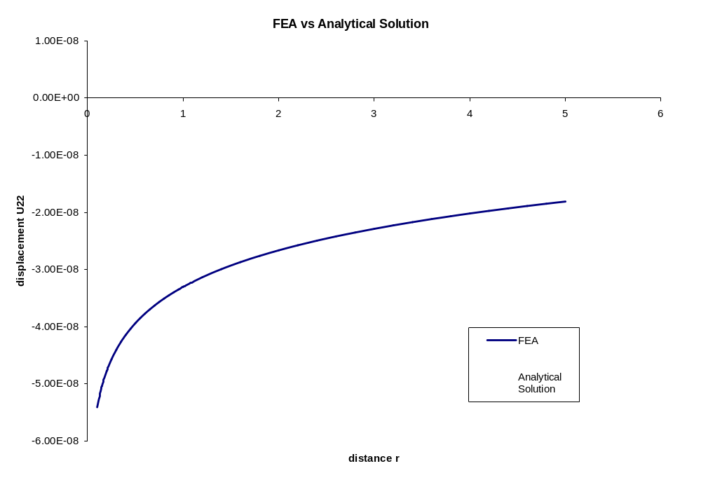
A difference between the FEA results and analytical solution can be seen. It is due to the constant C. C is estimated to be 2~4E-08.
Discussion:
During the analysis process, problem such as distorted elements and “aspect ratio exceeding 100 to 1” are encountered. Also, when dealing with the point-load problem, acceptable answers cannot be obtained when cutting the objective in half, even the mesh is very fine.
Also, an important discovery is found that when solving the second problem, the FEA results for stress will vary with the thickness of the objective. For example, if the thickness is 1000, then the FEA results should be multiplied by 1000 to match the analytical solution. This can be also discovered when looking at the analytical solution formula: . The unit of P should be N, and r has the unit of m. Then the right hand side of this equation has the unit of N/m. However, the stress should have the unit of N/m². Therefore, it can be deduced that there may be a missing factor dealing with the effect of thickness.

